**Experiment Title-1:** **Introduction To DBMS, RDBMS, ORACLE, Basic SQL Commands**

**Student Name: Neha Sharma UID: 20BCS4576**

**Branch: CSE-IOT Section/Group: A**

**Semester: 3RD Date of Performance: 18-08-2021**

**Subject Name:- DBMS Subject Code: 210-20CSP-233**

**1. Aim/Overview of the practical:** **Introduction To DBMS, RDBMS, ORACLE, Basic SQL Commands**

**2. Task to be done: Explain in Detail, DBMS, RDBMS,ORACLE and differentiate between them. Also elaborate basic SQL Commands**

**3. Apparatus (For applied/experimental sciences/materials based labs): No**

**4. Algorithm/Flowchart (For programming based labs): No**

**5. Theme/Interests definition ( For creative domains):**

* **DBMS:** A Database Management System (DBMS) is software designed to store, retrieve, define, and manage data in a database. **It** is a software for storing and retrieving users' data while considering appropriate security measures. It consists of a group of programs which manipulate the database. The DBMS accepts the request for data from an application and instructs the operating system to provide the specific data. In large systems, a DBMS helps users and other third-party software to store and

retrieve data.

* **RDBMS:** A relational database management system (RDBMS) refers to a collection of programs and capabilities that is designed to enable the user to create, update, and administer a relational database, which is characterized by its structuring of data into logically independent tables.
* **ORACLE database:** Oracle database is cross-platform. It can run on various hardware across operating system including window server, Unix, and various distributions of GNU/LINUX. It has its networking stack that allows application from a different platform to communicate with the Oracle Database smoothly. For example, applications running on windows can connect to the oracle Database running on Unix.
* **Basic SQL Commands:**

**There are five types of commands:-**

1. **DDL:-** DDL changes the structure of the table like creating a table, deleting a table, altering a table, etc.

**some commands that come under DDL:-** **Create, Alter, Drop and Truncate.**

1. **DML:-** DML commands are used to modify the database. It is responsible for all form of changes in the database.

**some commands that come under DDL:- Insert, Delete and Update.**

1. **DCL:-** DCL commands are used to grant and take back authority from any database user.

**some commands that come under DDL:- Grant and Revoke.**

1. **TCL:-** TCL commands can only use with DML commands like INSERT, DELETE and UPDATE only.

**some commands that come under DDL:- COMMIT, ROLLBACK and SAVEPOINT**

1. **DQL:-** DQL is used to fetch the data from the database.

**It uses only one command:- SELECT**

**6. Steps for experiment/practical:**

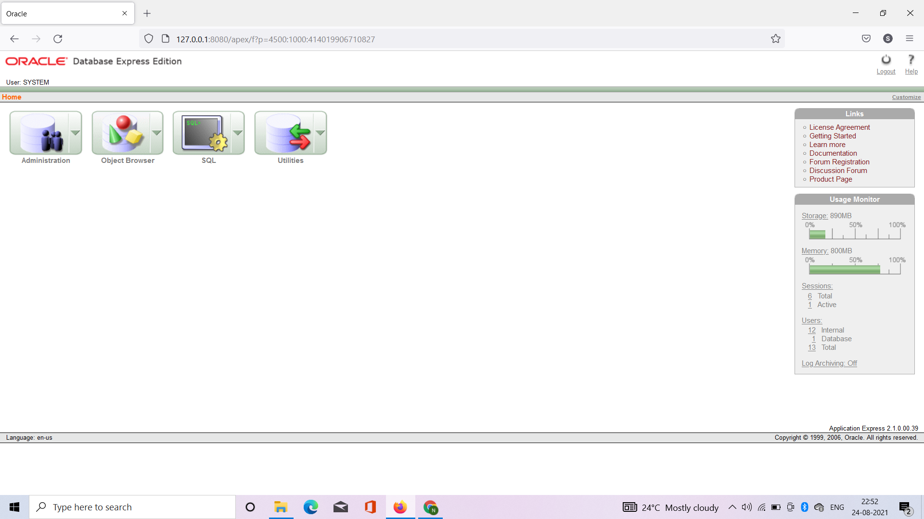

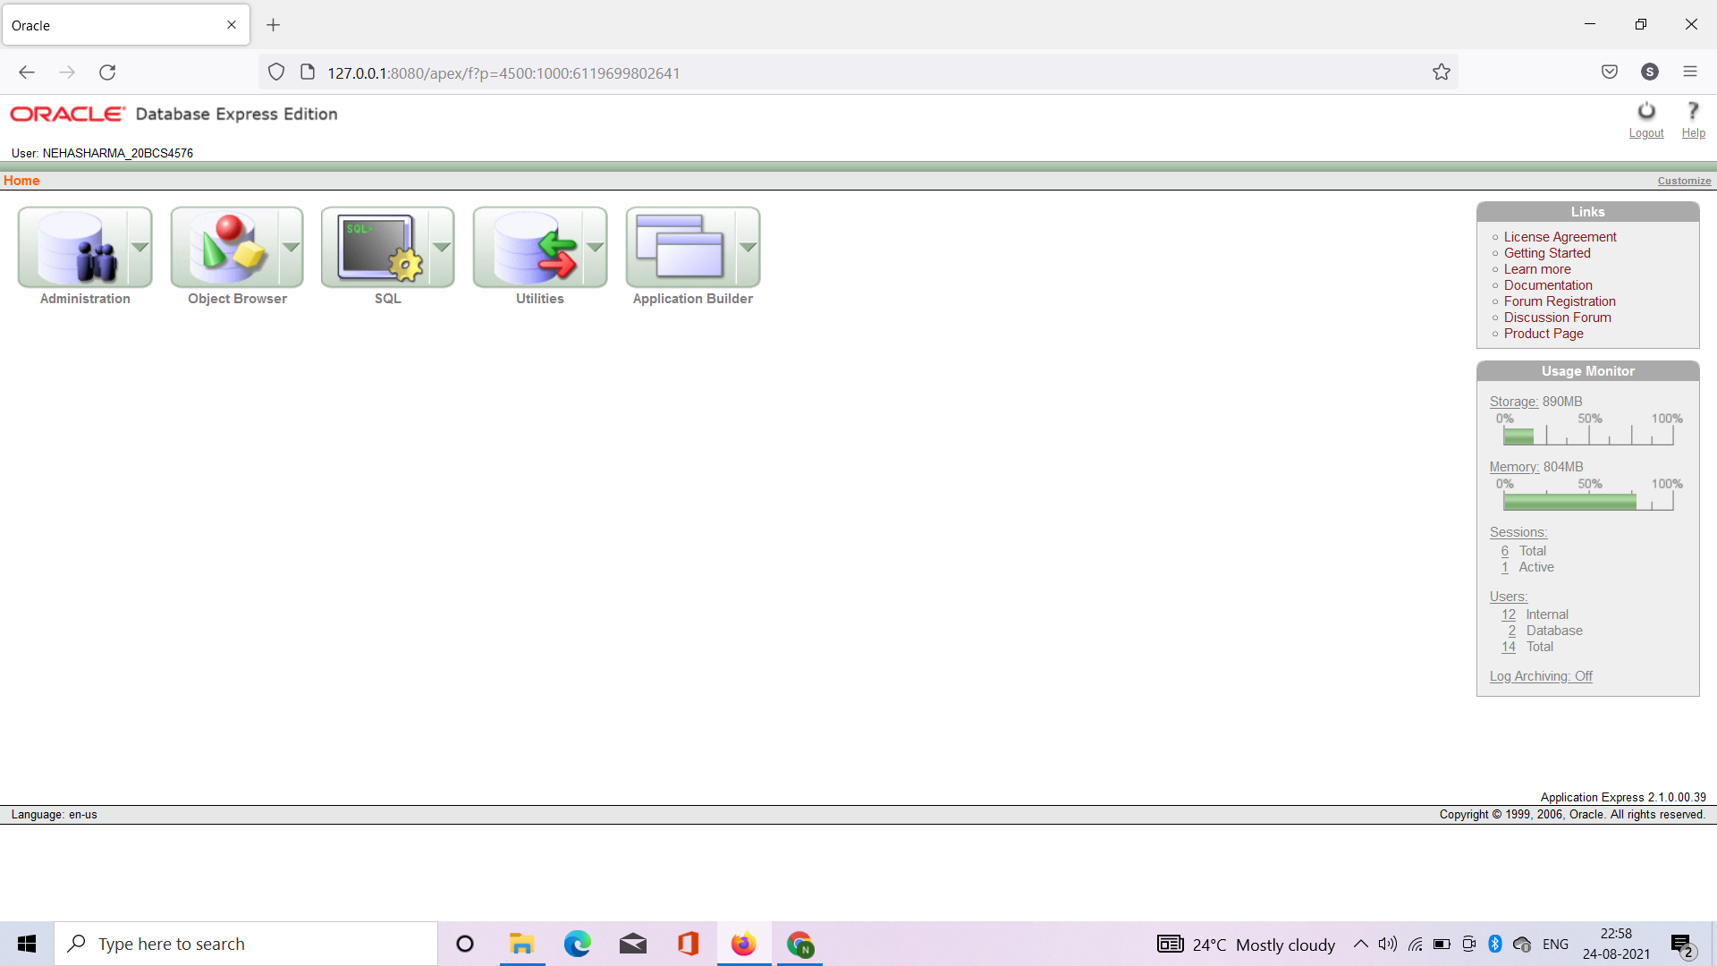

**7. Observations/Discussions (For applied/experimental sciences/materials based labs): NO**

**8. Percentage error (if any or applicable): NO**

**9. Calculations/ Chemical Reactions / Theorems /Formulas used etc : NO**

**10. Result/Output/Writing Summary: NO**

**11. Graphs (If any): Image/Soft copy of graph paper to be attached here:- NO**

**Learning outcomes (What I have learnt):**

**1. Introduction to DBMS**

**2. RDBMS**

**3. Oracle**

**4. Basic commands of SQL**

**5. Installation of Oracle Database 10g**

**Evaluation Grid (To be created as per the SOP and Assessment guidelines by the faculty):**

|  |  |  |  |
| --- | --- | --- | --- |
| Sr. No. | Parameters | Marks Obtained | Maximum Marks |
| 1. |  |  |  |
| 2. |  |  |  |
| 3. |  |  |  |
|  |  |  |  |